**WEB422- Group1-Test5**

**YuChe-#134378179**

**Alisson Franco-#151277183**

***Step 2****: After you open the modules on VSCode, you just need to follow these steps:*

* On the terminal, type $**ng test**
* Then the application will run by itself 3 tests and it will open a browser saying how many modules ran and how many we obtained success.
* In our case we ran 3 modules and we obtained 3 successes.
* The whole process used the Karma test.

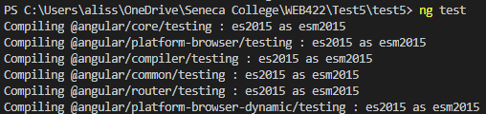

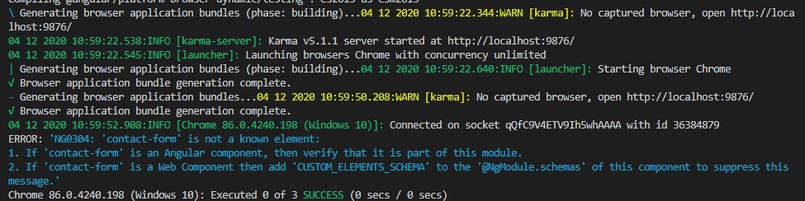

***Step 3****: How do you deploy the App in Heroku? Write the required steps.*

1. Create an app in heroku( in this case, I will use the name as web422-test5-group1)
2. Go to the terminal , under the correct file path, enter $heroku login
3. $ git init
4. $ heroku git:remote -a web422-test5-group1
5. $ git add .
6. $ git commit -am "make it better"
7. $ git push heroku master
8. Now it’s all set on Heroku